book based Storyline
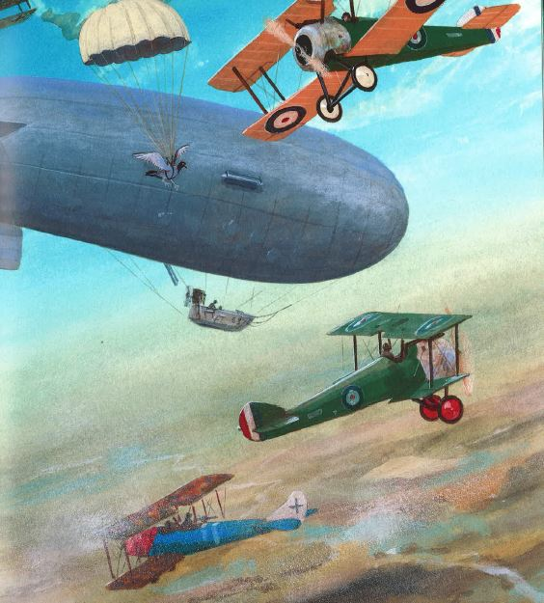

The big war
Based on the books ‘De oorlog’ (The war), Anaïs Vaugelade
‘De grote oorlog’ (The big war), Martijn van der Linden

Plot : peace education, commemoration of the First World War
key words: war, peace, memory education, inheritance, system thinking

Storyline with respect to commemorative education

Why would we confront children in the classroom with the First World War? Are they capable to understand this topic?
Will they not be frightened? Is this not more appropriate or suitable for the secondary education? All these questions are perfectly understandable when opening this manual.

Research has revealed that themes such as war, sorrow, fear, death,…. should not be banned from the children’s world. They are a part of life. Via the media, young children are getting acquainted with these items. In 2014, a wide range of commemorative events are held on the occasion of the breakout of the First World War. Infants and young children can certainly learn from it, and we are in fact convinced that the children who are properly introduced with moral themes at an early age, will be able to make better moral choices as adults.

This conviction is confirmed by research undertaken by Dr. C. van der Pol:
Literary testimonies and picture books about the war can, each in their own manner, introduce people to the large, and often anonymous and abstract story of the war. The texts and drawings invite us to identification with the authors or the characters because they tell us the story of real people, with a name and a face. These people are part of a family, they had their proper activities and had high hopes for the future. The war thwarted everything. The books make us face these facts, they are forcing us to ask the following question: What would I do?
(Source: PhD. General Cultural Sciences, University of Tilburg, NL, Coosje van der Pol, August 2005)

With this manual, we hope to help out the teachers of children in order to tackle the notion of ‘war’ in the classroom.
Or, as the (Dutch) saying goes: don’t keep me quiet, but talk me to life….

Storyline ‘The big war’: an introduction
Our book based storyline “The Great War” plunges children in the middle of a fictional war. They identify themselves with Joris, Prince of the Blues, and his animal friends: Sheep, Dove, Cat, Dog, and Cow. In this safe fictional world, children aged between 5 and 8 can look through the eyes of Joris, the antihero, who rides on a sheep and discovers the meaning of a war between grown-ups. His animal friends report through the different episodes on land, sea and air activities, and on the behavior of soldiers and citizens.
In this Storyline children are challenged to think about moral issues and to learn about the specific conditions of war. How can they, together with Joris, end this war? What choices they have when confronted with war? Through these and other key questions they unravel the complexity of war, and how it shatters daily routine.
Teachers can make the link with the commemoration of the Great War or with actual conflicts. To assist the teacher, there is the narration, an edited version of the book ‘De oorlog’, by Anaïs Vaugelade, but also the wall charts from the beautiful wall chart book ‘De grote oorlog’, by Martijn Van der Linden. Further, the classical concept of the wall frieze is broadened with a so-called behavior graph which allows the group to visualize Joris’ feelings throughout the story.

And how it ends...? Well, have a look at http://flandersfields.weebly.com or www.Storylinegent.be.

Episode 1: Joris and his friends

Storyline | Key questions | Learning activities | Equipment
Story: see episode 1 | What is war? How does a war start?  What kind of people are involved in a war? (who participates, who doesn’t,…)  How did Joris got involved in the war between the Reds and the Blues? | The teacher reads episode 1 of the story for the circle of pupils.  Circle moment: discussion of the story. | wall chart:  - the pond
 | What would Joris look like?  What kind of clothes is soldier Joris wearing? | Group work/partner work/individual work:  Construction of Joris as a three-dimensional figure in several fractions:  - head, face and hair  - body  - arms  - legs  - clothing: to draw the uniform of a Blue soldier and search for parts to construct it (maybe sew it)  some pupils make a soldier’s helmet of the Blues, using their own fantasy… | craft material such as nettings, newspapers and glue (papier-maché), paint, fabric, scissors, shoes, clothing or rags of fabric, sewing material or safety pins, wool,…  balloons, glue, scissors, newspaper, paint (papier maché)
 | How does Joris feel now ? Why is he feeling that way?  What did we learn? | Class instruction: discuss and frame the behavior graph. Attach it next to Joris. (see appendix ‘what is a behavior graph’).  Circle moment  At the end of this episode Joris will be ‘installed’ in a corner of the class room. All the works of the pupils (design of the uniform, the helmets, the behavior graph, …) will be attached to the wall next to Joris and the discussion wall chart: this is the start of the wall frieze.  We repeat the new vocabulary and say goodbye to Joris (this ritual will be repeated during each episode) | long strips of paper, symbols, felt-tip pens, possibly rope in order to show the diagram.  word cards with vocabulary: war, helmet, soldier, uniform

Episode 2: At land, at sea and in the air

Storyline | Key questions | Learning activities | Equipment
Story: see episode 2 | What is happening with Joris and his friends? | The teacher reads episode 2 of the story for the circle of pupils.  Circle moment: discussion of the story (in general) and the wall charts (more in detail). | wall charts:  - the front  - scars in the landscape  - medical service  - at sea  - in the air
 | discussing wall charts 2 and 3:  What are trenches?  What do Joris and his friends see in the trenches?  discussing wall chart 4:  What does Cat see behind the front line? How does a nurse put on a bandage?  discussing wall chart 5:  What does Joris see at sea? Why is the sea important during the war?  Discussing wall chart 6:  What kind of scenery does Pigeon see when she looks down?  How do you make beautiful poppies for Joris? | Optional corners with activities on cards, supported by films (see attachments)  Make a stop motion film of a miniature scene from the trenches  First Aid: put on bandages on/around various parts of the body  Play battleships  make a fantasy card of the battlefield between Reds and Blues  make paper poppies | Sand table, toys, photo camera, an appliance to imitate sounds, computer,…  bandages, gauze roller-bandage, compress,…  battleships game boards  large sheets of paper, colors, paint, magazines, scissors,  crêpe paper, sticks
 | What did we learn?  How does Joris feel now? Why is he feeling that way | circle moment:  complete the wall frieze, the pupils explain what they made.  To repeat the new vocabulary  We discuss and complete this part of the behavior graph of Joris. | word cards with vocabulary: trenches, front, sea-battle, the Red Cross, poppy

Episode 3: And then it became silent…

Story line | Key questions | Learning activities | Equipment
Joris is holding a letter in his hands when the children enter the classroom.  Story: see episode 3 | What is happening with Joris and his friends? | The teacher reads episode 3 of the story for the circle of pupils.  On the right moment a pupil reads the letter or the teacher reads it. Circle moment: discussion of the story (in general) and the wall charts (more in detail). | Letter of Julius The Red parchment or paper, made with coffee grounds, red ink, sealed wax, red ribbon  Discussing wall charts:  - to run away  - behind the front
 | Discussing wall chart 7:  What would you do during the war: stay or run?  Discussing wall chart 8:  What do Joris’ friends tell about the life of the normal people and animals behind the front? | class:  active group game: stay or run (see attachment)  organize a ‘hunger meal’: prepare soup and eat it in group  learn and practice a song (see attachment) | open space  cooking stove, vegetables, bread, cutlery
 | What did we learn?  How does Joris feel now? Why is he feeling that way | Circle moment:  to repeat the new vocabulary  We discuss and complete this part of the behavior graph of Joris. | word cards with vocabulary:  hunger, meal voucher, ration, to run away
Episode 4: To commemorate
Story line | Key questions | Learning activities | Equipment
story: see episode 4 | What happens with Joris and his friends? How does the war end? | The teacher reads episode 4 of the narrative story for the circle of pupils.  Circle moment: discussion with regard to the end (of the war)
 | How can we commemorate together with Joris the end of the war?  Why do people commemorate a war?  How can we make sure that there will never be a war again? | Circle moment: watch a movie of ‘the last post’  Group work:  decorate the helmets with the self-made poppies. Pupils can possibly make more flowers in order to create a work of art to commemorate the war.  excursion:  pay a visit to a war memorial site in the neighborhood where the pupils place the work of art. | craft material  computer, beamer
 | What did we learn?  How is Joris feeling now?  Why is he feeling that way? | To repeat the new vocabulary  We discuss and complete the behavior graph of Joris. | word cards with vocabulary:  To commemorate, monument

