TOGETHER

Information

The First World War is the most renowned trench warfare, but other wars also included trenches.
A trench is a ditch in the ground, mostly a solid construction of sandbags and planks. Soldiers are sheltering in the trenches to shoot and to defend themselves against enemy fire.
Life in the trenches was hard: diminishing food supplies, often wet and muddy and barely any sleep. An attack was terribly frightening and dangerous, but the intervals were extremely boring and soldiers were harassed by lice, flees and rats.

Assignment

Make a genuine trenches warfare film!

Use the following procedure:
A funny film technique is Stop Motion, and especially Claymation, you know what I mean, somewhat jerky films with clay puppets that are displayed in constantly changing attitudes.
When using Stop Motion, the camera makes image-by-image recordings. Make sure that the camera is not moved, the only thing that is somewhat changing is the image that you can see through the lens. When playing the recorded images, it seems as if the objects are moving from themselves!
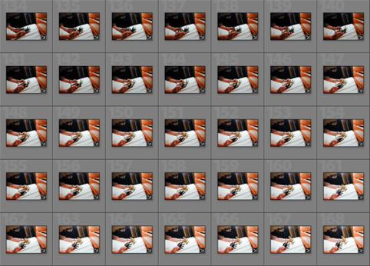
http://www.youtube.com/watch?v=gS5Vqb7VTc

http://www.youtube.com/watch?v=zRbe2GDjZRI

